HOW TO CHANGE A POSTING DATE IN GENERAL LEDGER
- You will need the run# from the original posting in order to change the posting date of the posting. You can find this number by looking at the actual posting register and it will be located in the title of the report. You can also look in the general ledger detail and it will be located on the posting line.

Advanced Box Company V10.0 - Main Office Page 1
Invoice Posting - Detail - RUN# 425

- Go to N-R (Network System Administration – Run Customer Utility)
- Type in util/changper.r in the space provided.
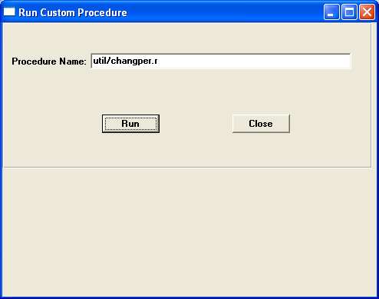
- A screen will pop-up where you will enter the run# and press tab.
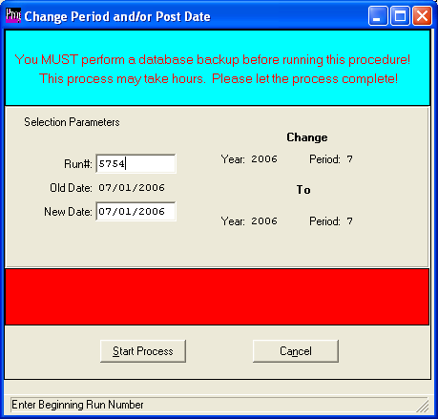
- Change the New New date to the posting date desired and press the start process button. Your posting date is now changed for all records of that posting in the general ledger.

